**Sequence Diagram**

**Manage Crisis:**

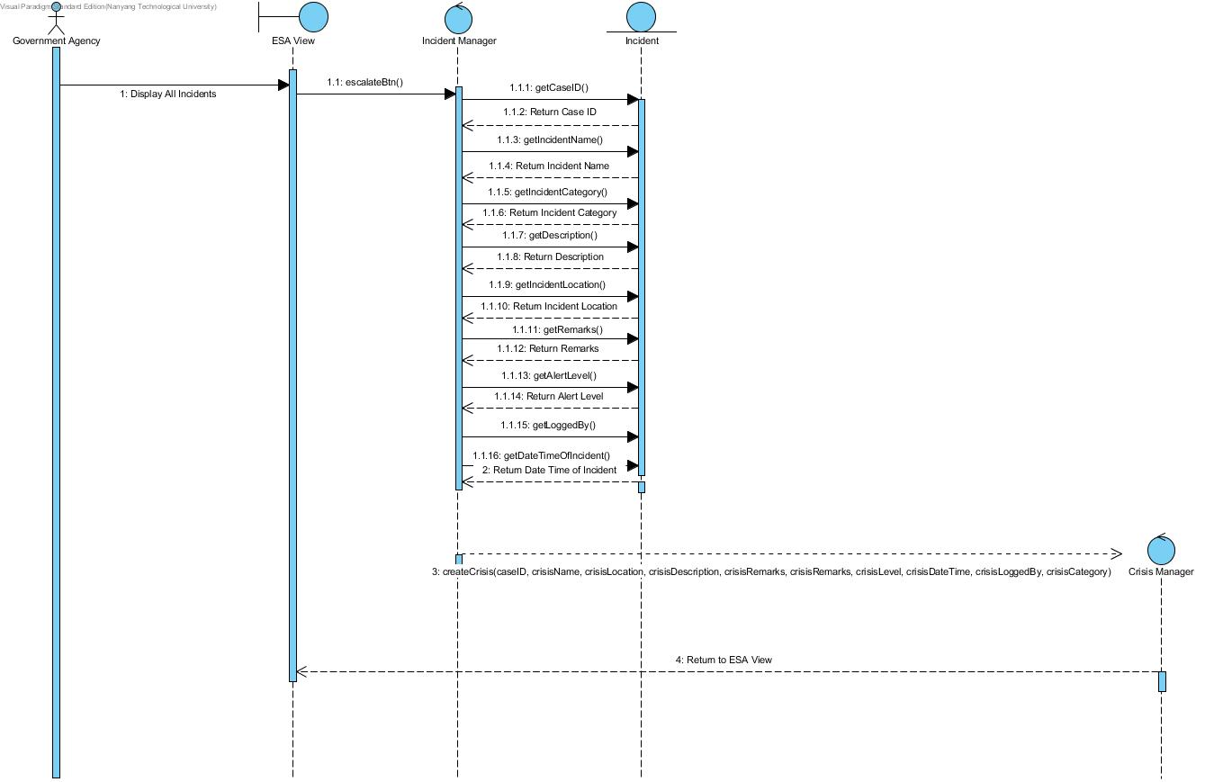

**Monitor Incident:**

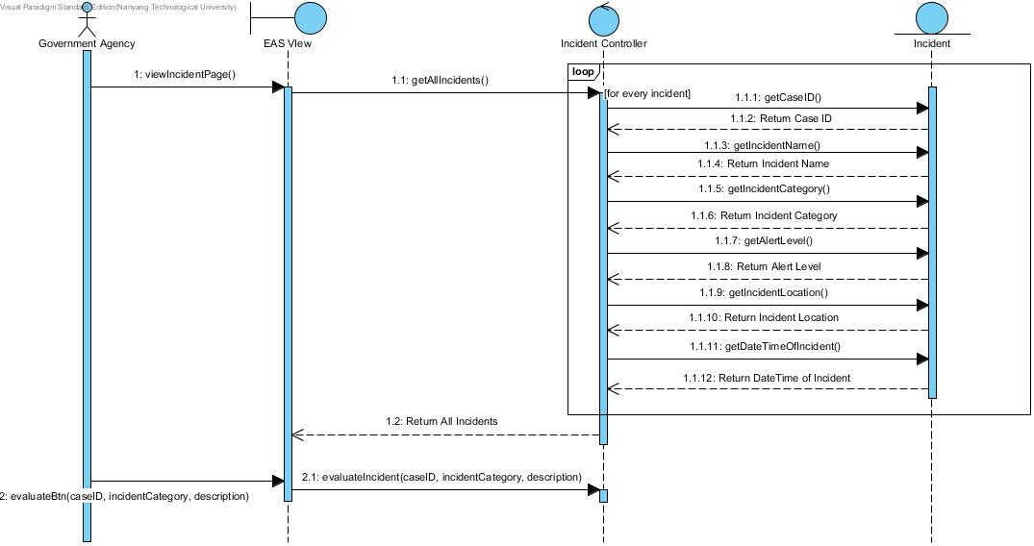

**Notify Public:**

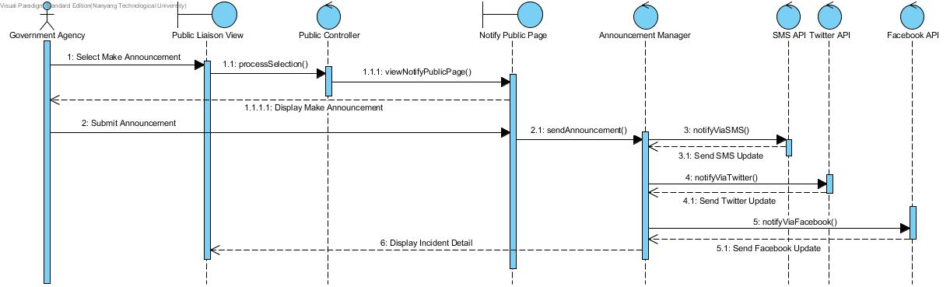

**Command Asset:**

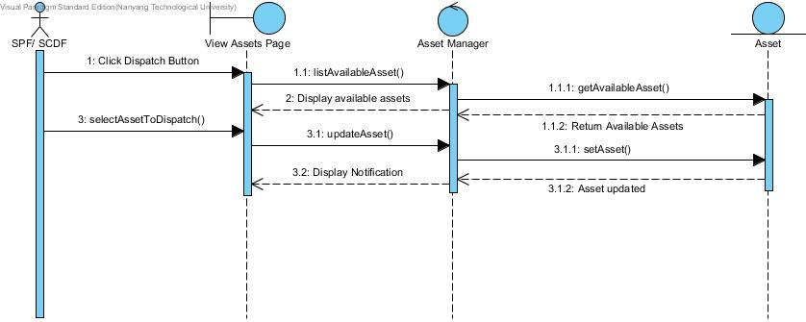

**PMO Status:**

